

Vietnamese Study System for Japanese

INSTALLATION GUIDE DOCUMENT

Project Code: Veazy

Document Code: Veazy_Installation Guide_v1.0_EN

**Ha Noi, 10/08/2016**

Record of change

*A - Added M - Modified D - Deleted

|  |  |  |  |  |
| --- | --- | --- | --- | --- |
| Effective Date | Changed Items | A* M, D | Change Description | New Version |
| 10/08/2016 |  | A | Add new | v1.0 |
|  |  |  |  |  |
|  |  |  |  |  |
|  |  |  |  |  |
|  |  |  |  |  |
|  |  |  |  |  |
|  |  |  |  |  |
|  |  |  |  |  |
|  |  |  |  |  |
|  |  |  |  |  |
|  |  |  |  |  |
|  |  |  |  |  |
|  |  |  |  |  |
|  |  |  |  |  |
|  |  |  |  |  |
|  |  |  |  |  |
|  |  |  |  |  |
|  |  |  |  |  |
|  |  |  |  |  |
|  |  |  |  |  |
|  |  |  |  |  |

SIGNATURE PAGE

ORIGINATOR: Đào Thanh Tùng 10/08/2016

Team member

REVIEWERS:

APPROVAL: Nguyễn Văn Sang

Supervisor

# Installation guide

## Introduction

This document contains guide-lines step by step to deploy Veazy website, and set up its own database.

## Environment

Following are the software required to start the Veazy System:

* Operating System: Windows 7, Windows XP, Windows 8, Windows 10
* JDK 8
* Browsers: Firefox 20, Chrome 36 or higher.
* Database: PostgreSQL 9.3 or higher

## Application Installation

### Set up Environments:

* Web: If users want to use Veazy system on personal computer, users need to install Chrome36 /Firefox 20 or higher version and PostgreSQL to create and store database.
* Server

### Install PostgreSQL 9.5.3

* Go to link:

[http://www.enterprisedb.com/products-services-training/pgdownload#windows](http://www.enterprisedb.com/products-services-training/pgdownload%23windows%20)

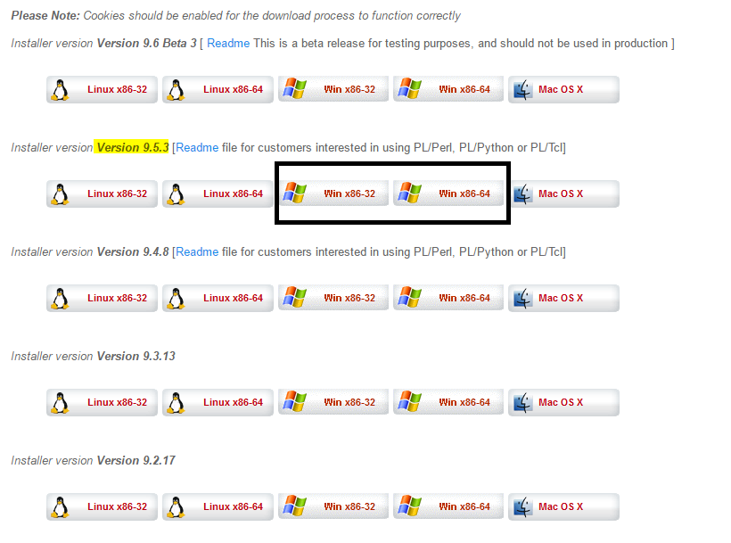

* Select PostgreSQL version 9.5.x and download.
* Run downloaded file follow the below steps

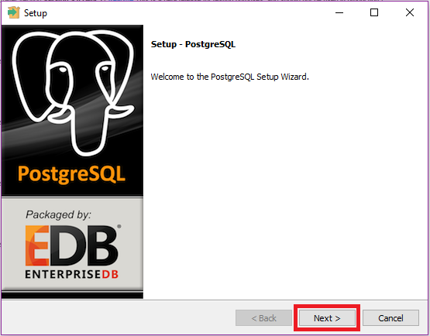

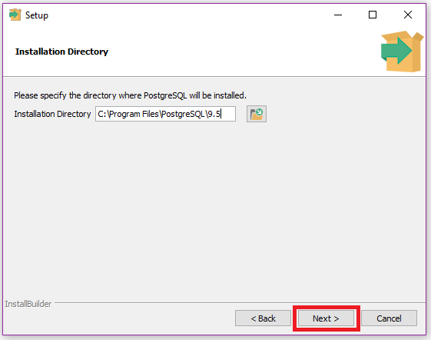

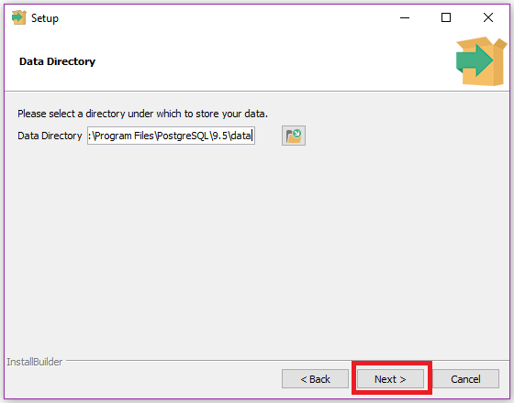

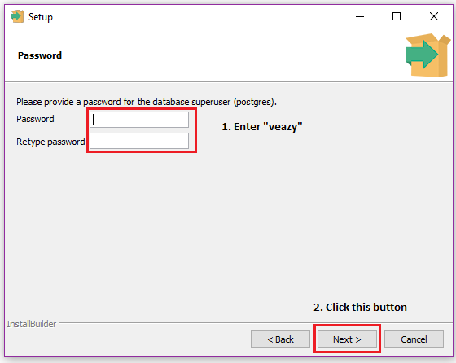

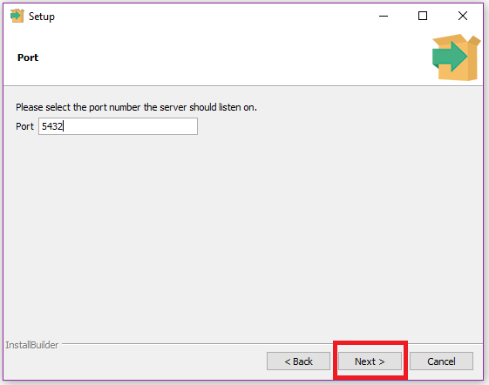

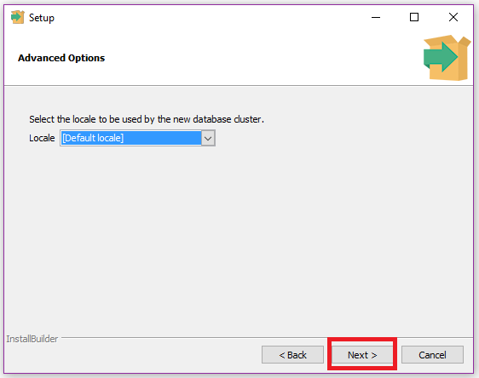

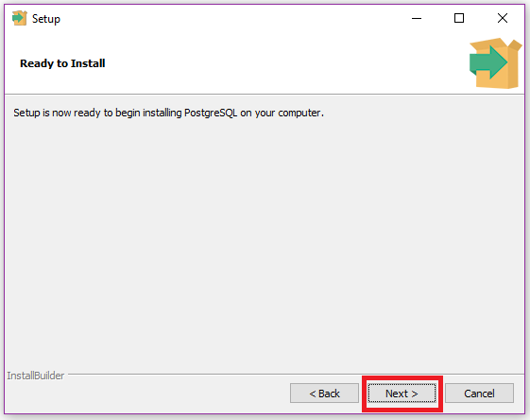

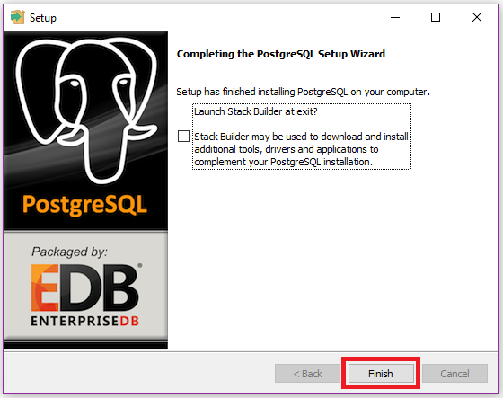

### Create Database

* Open “pgAdmin III”

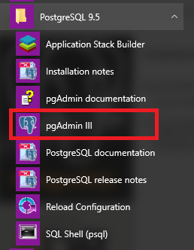

* Create new role

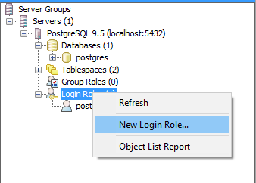

* Enter “veazy” to “Role name” box

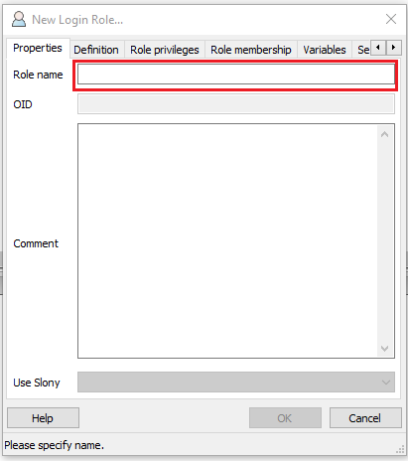

* Select “Definition” tab and enter “veazy” to password box

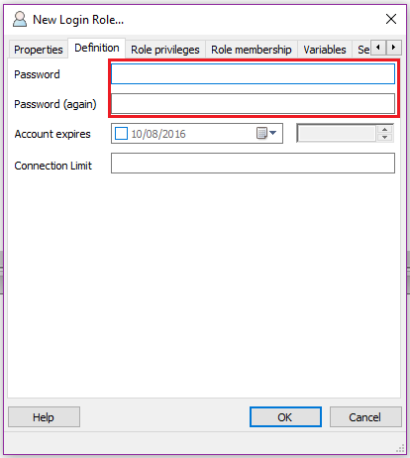

* Click “OK” button and see new role “veazy” has been created.

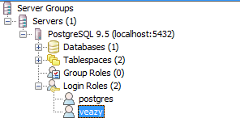

* Create new database

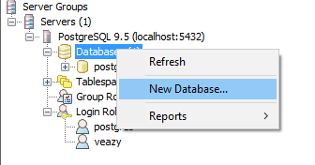

* Enter “veazy_system” into “Name” box and select “veazy” in “Owner” drop-down list

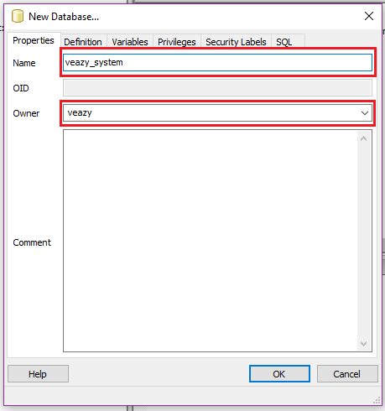

* Click “OK” button and see new database “veazy_system” has been created.

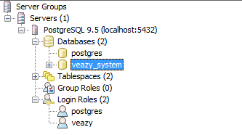

* Click  button on toolbar



* Click button on toolbar of new window



* Open “veazy.sql” file

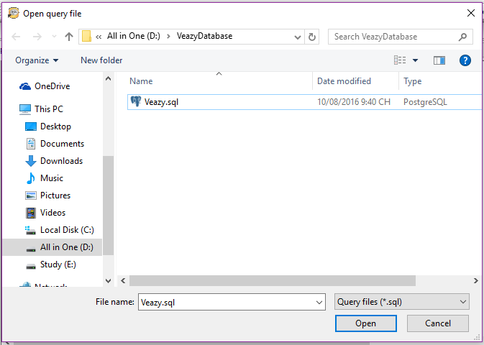

* Click  button on toolbar to run script



* Database was created with some table that contained data

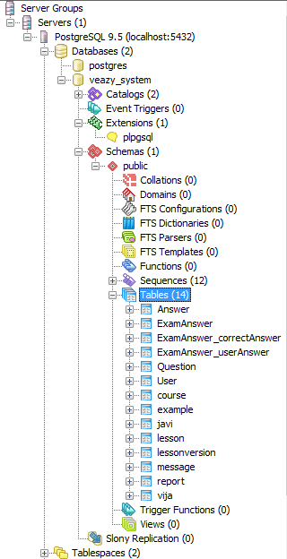

### Install JDK 8

* Go to link

<http://www.oracle.com/technetwork/java/javase/downloads/jdk8-downloads-2133151.html>

* Download JDK 8

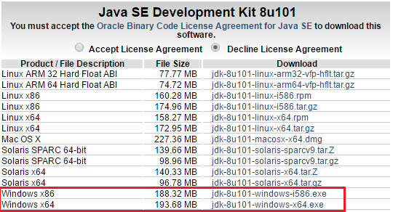

* Run downloaded file follow the below steps

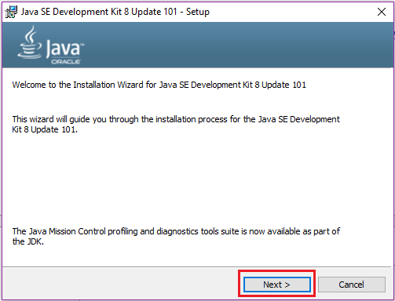

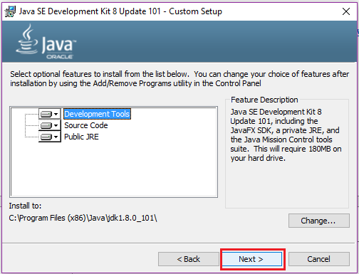

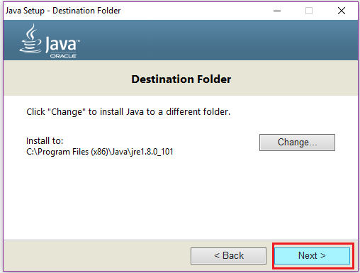

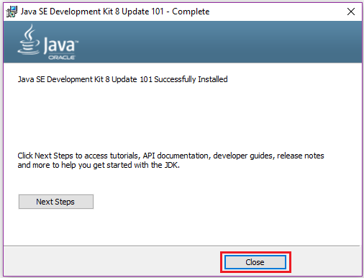

### Install Tomcat 7

* Go to link

<https://tomcat.apache.org/download-70.cgi>

* Download Tomcat 7

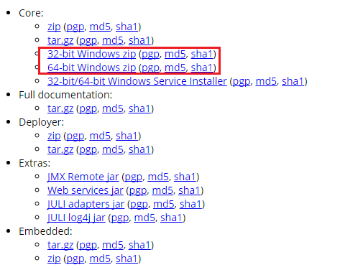

* Extract downloaded file and see extracted folder

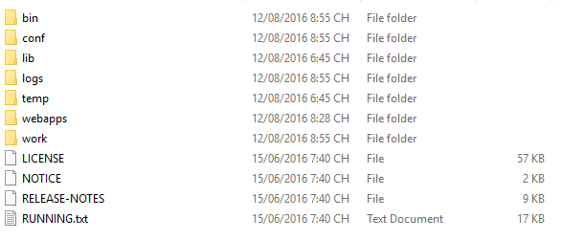

## Deploy server

* Copy file “Veazy.war” to “webapps” folder inner Tomcat folder

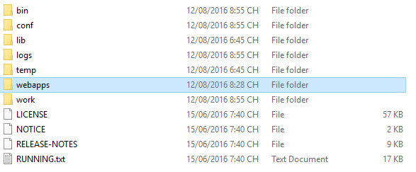

* Go to “bin” folder and run “startup.bat” file

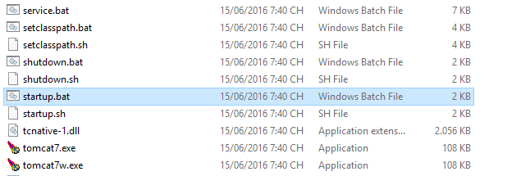

* Wait until the operation finish

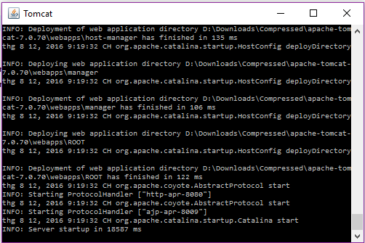

* Open browser and enter “localhost:8080/Veazy/” into address box and see deployed website

# Appendix

* ~~Veazy_Software requirement specification_v1.2_EN~~
* ~~Veazy_Defects Log Management_v1.0_VN~~
* ~~Veazy_Q&A Management Sheet_v1.0_JS~~